Android Studio dota merketplace

Note : Sorry mam/sir, this file is too big, i can’t put this code on github, so, this is the screenshot of my android studio Dota marketplace. Thankyou

* Login

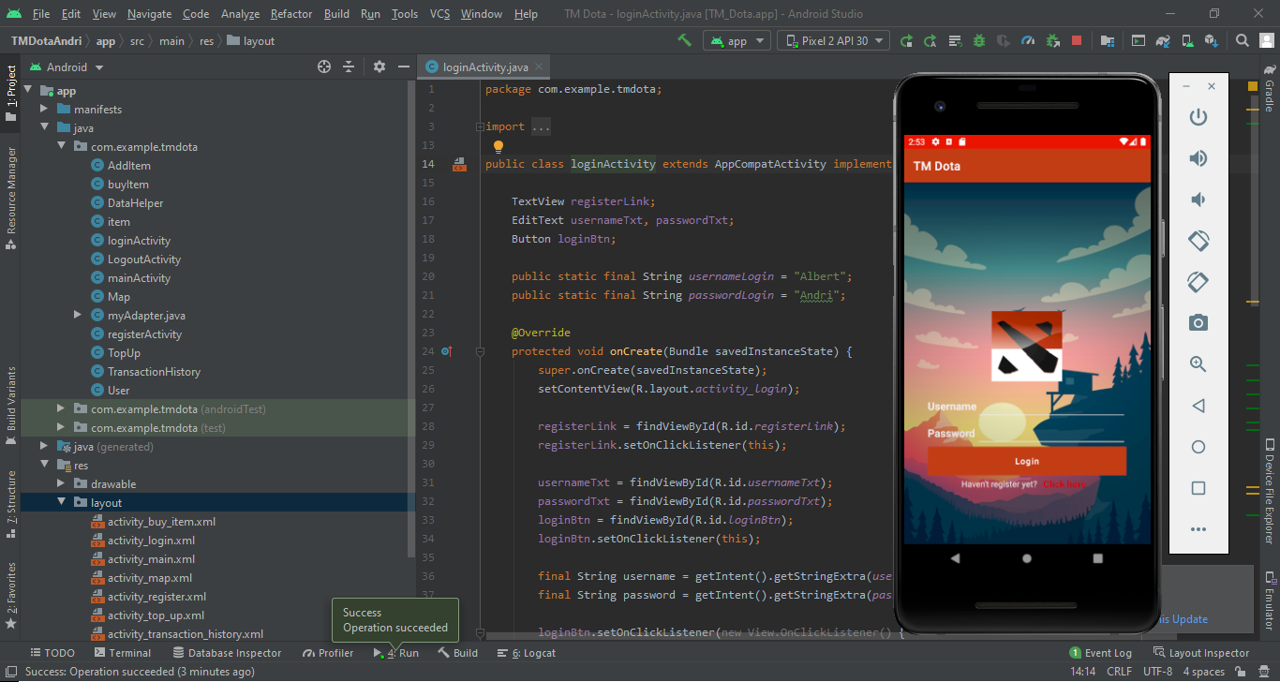So, this is the login page, user must login with their account that have been registered.

* Register

Their are many validation here like numeric, aplhabet and many more. After registered, user must login with their data that have been registered, if user didn’t do that, it will be error.

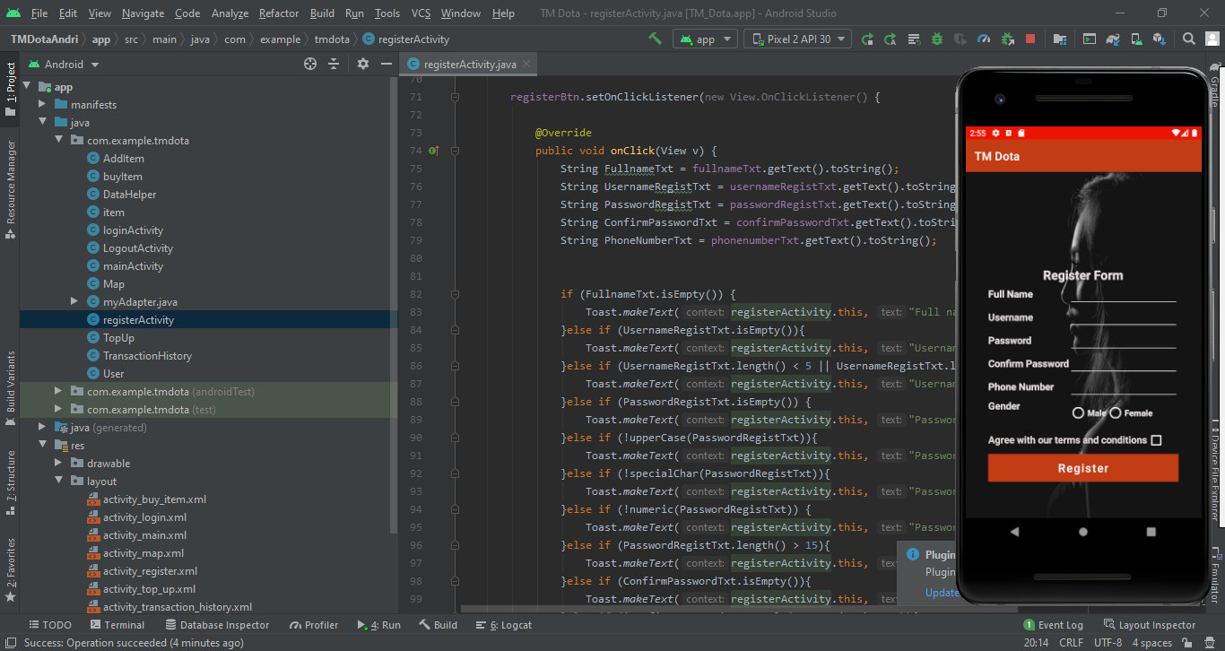

* Main

User can buy the skin, logout and topup. Skin that choosed by the user will redirect to buy form.

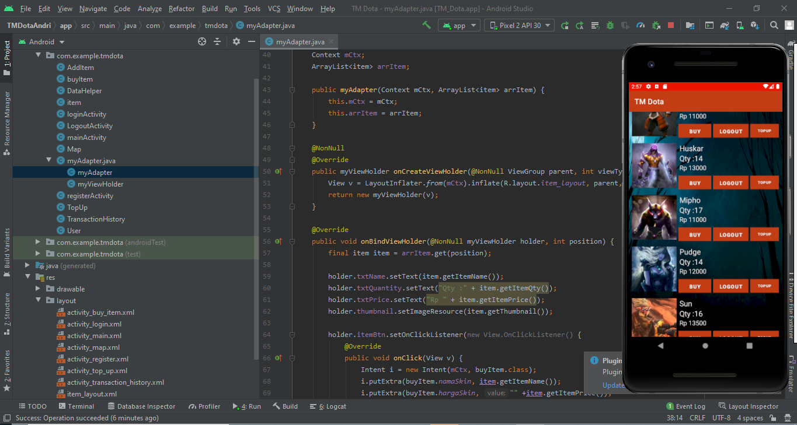

* Buy form

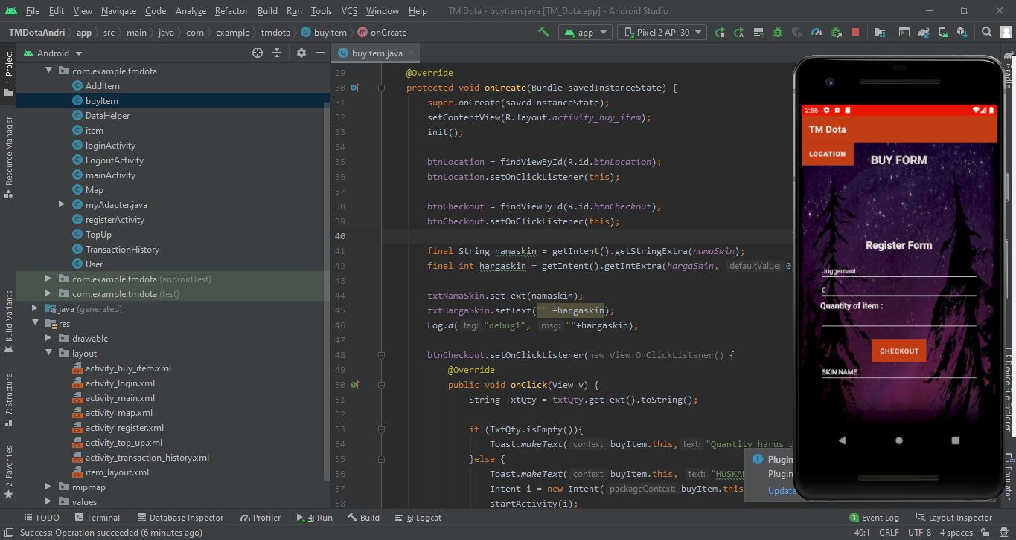Buy form will show what skin name that been choosed by the user.

* Map

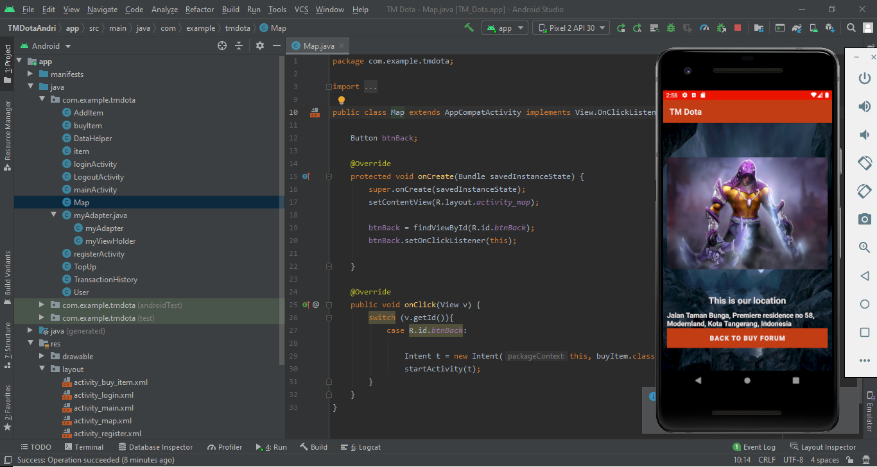This is dota location, only intent from one activity to another activity.

* Top up form

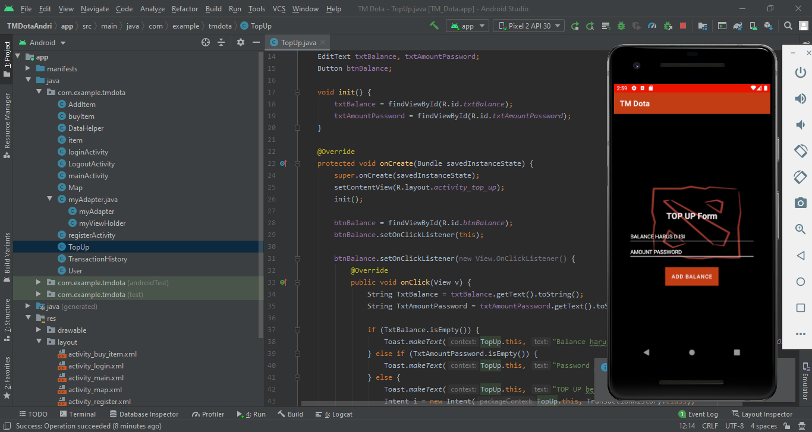User can top up their account.